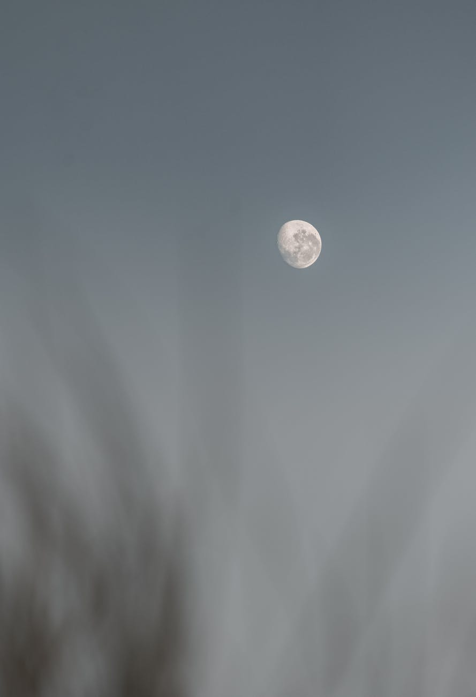

Sleep

Oh, Iwonder why it is, I must sleep

And loose more doings I could keep

In our dreams we only have thoughts

Inour wake we build our lots

Each night when I see my bed

I think that soon I maybe dead

Oh, I dread that softly looking box

That one flaunting those shinney looking locks

Locks that will soon fade and rust

Yet not release that, held in trust

Soon all held will turn to dust

Only becoming a cosmic matter of must

This however should not be a strain

From there onward my soul will reign

Simply this mandatory change Ino worry

Yet still I am in no great hurry

Clifford D.Cope